Real-time Operating System - 48450

Assignment 2 Report

Student Name:

Student ID:

**Table of Contents**

I. Introduction 2

II. Implementation 2

1. Method 2

2. Flow chart and/or Gantt Chart 2

III. Experiments 2

IV. Conclusion 3

V. References 3

1. Introduction

In this section, an introduction about the assignment is presented and some core technical knowledge that you will use are highlighted.

1. Implementation
2. Method

In this section, you are required to list the concepts that are used to fulfil the design in your program.

1. Flow chart and/or Gantt Chart

You might draft a flow chart and/or a Gantt chart about your program.

1. Experiments

For demonstration purpose, you might give some graphs about your program running. An example is shown below.

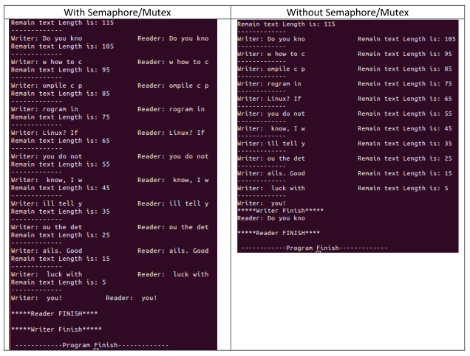

Figure 1. Sample of the figure -- Experimental results with and without semaphore/mutex.

1. Conclusion

You might give a summary about your work on the assignment 2. What you have learned and your expectation

1. References

If you have references, please referee them correctly.

A. Silberschatz, P. B. Galvin & G. Gagne, 2012, Operating System Concepts, 9 th edn, John Wiley & Sons, New York.